*Heaven’s light is our guide.*

**Rajshahi University of Engineering and Technology**

**(RUET)**

**Department of Electrical & Electronic Engineering**

**Lab Report**

**Course no.** EEE2204

**Course title:** Electronics III Sessional

**Submitted to:**

**Dr. Md. Samiul Habib**

Associate Professor

Dept. of Electrical & Electronic Engineering,

**Rajshahi University of Engineering and Technology.**

**Submitted by:**

**Ashraf Al- Khalique**

**Roll:** 1801171

**Session:** 2018-2019

Dept. of Electrical & Electronic Engineering,

**Rajshahi University of Engineering and Technology.**

***INDEX***

1. Experimental study of a clipper circuit using passive elements. 3
2. Experimental study of a clamper circuit using passive elements. 10
3. Experimental study of precision half wave and full wave rectifier circuits using Op-Amp. 16
4. Experimental study of a comparator and a Zero crossing detector circuit using Op-Amp. 22
5. Experimental study of an inverting Schimitt Trigger using Op-Amp. 29
6. Experimental study of a monostable multivibrator using 555 timer. 34
7. Experimental study of an astable multivibrator using 555 timer. 39
8. Experimental study of a FSK generator using 555 timer. 43
9. Experimental study of a square wave generator using Op-Amp. 47
10. Experimental study of a triangular wave generator using Op-Amp. 51

*Heaven’s light is our guide.*

**Rajshahi University of Engineering and Technology**

**(RUET)**

**Department of Electrical & Electronic Engineering**

**Course no.** EEE2204

**Course title:** Electronics III Sessional

**Experiment no**. 01

# **Experiment name**: Experimental study of a clipper circuit using passive elements.

**Submitted to:**

**Dr. Md. Samiul Habib**

Associate Professor

Dept. of Electrical & Electronic Engineering,

Rajshahi University of Engineering and Technology.

**Submitted by:**

**Ashraf Al- Khalique**

Roll: 1801171; Session: 2018-2019

Dept. of Electrical & Electronic Engineering,

Rajshahi University of Engineering and Technology.

**Date of experiment:** January 21, 2021.

**Date of submission:** January 28, 2021.

**Experiment no**. 01

**Name of the Experiment:** Experimental study of a clipper circuit using passive elements.

**Objectives:** Followings are the main objectives of this experiment,

1. To understand the theory of operation of the clipping circuit using passive elements.
2. To study the diode applications in a clipping circuit using passive elements.
3. To observe wave shapes that meet the clipping circuit’s needs.

**List of Components:**

1. AC voltage source (10Vpk, 100Hz, 0o)
2. DC power supply (5V)
3. Resistors (1kΩ; 1 piece)
4. Diode (1N 4007; 1 piece)
5. Oscilloscope
6. Project board
7. Connecting wires

**Circuit diagram:**



***Fig 1.1:*** *Circuit diagram for Biased series clipper circuit.*

**

***Fig 1.2:*** *Circuit diagram for Biased parallel clipper circuit.*

**Wave shape:**

1. **Biased series clipper circuit:**

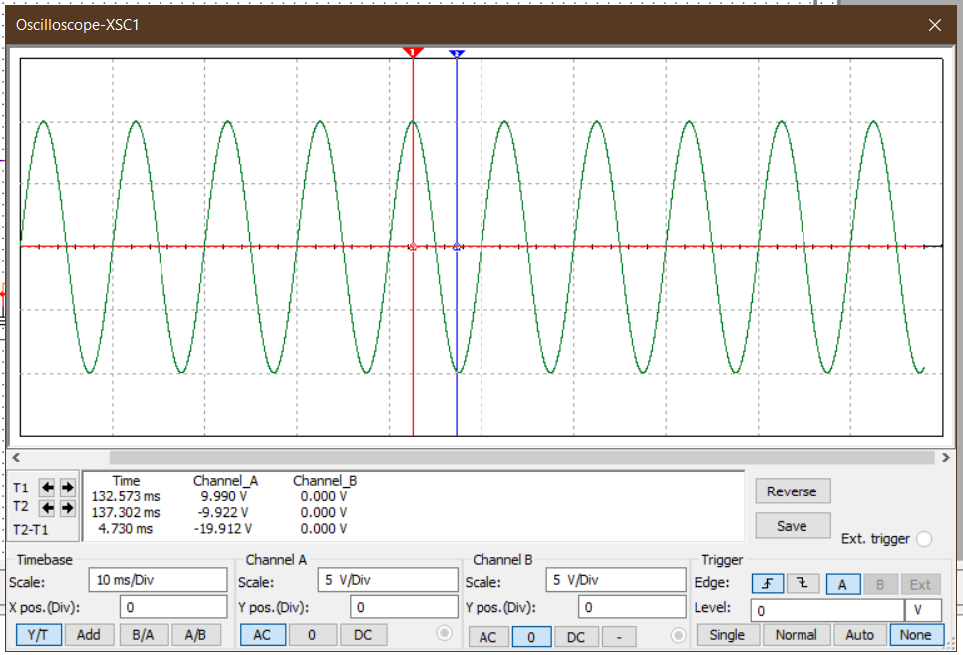

***Graph 1.1:*** *Input signal for biased series clipper circuit.*

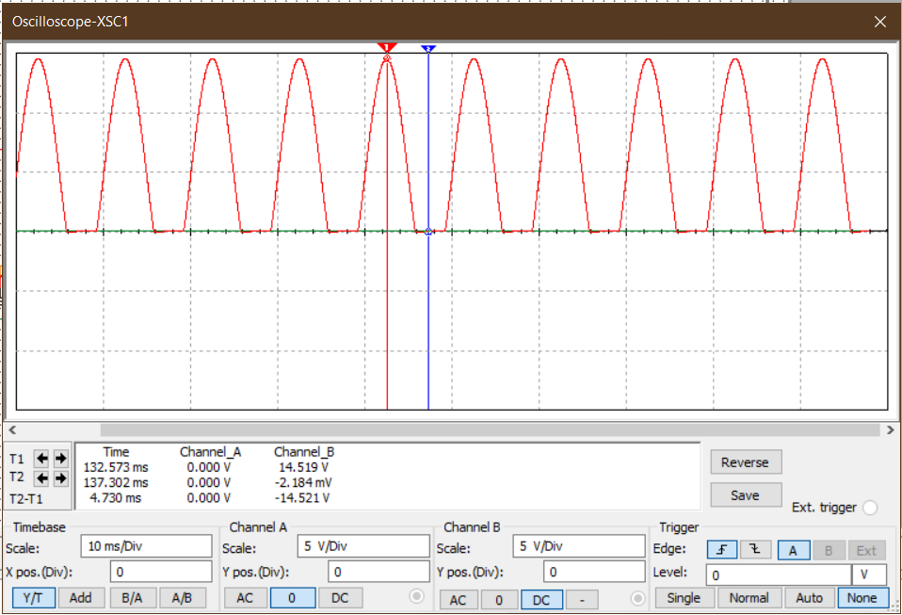

***Graph 1.2:*** *Output signal* *for biased series clipper circuit.*

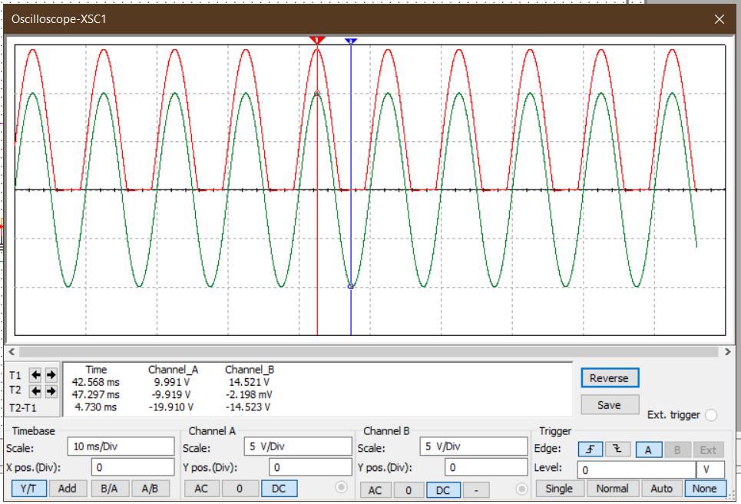

***Graph 1.3:*** *Input and output signal for biased series clipper circuit.*

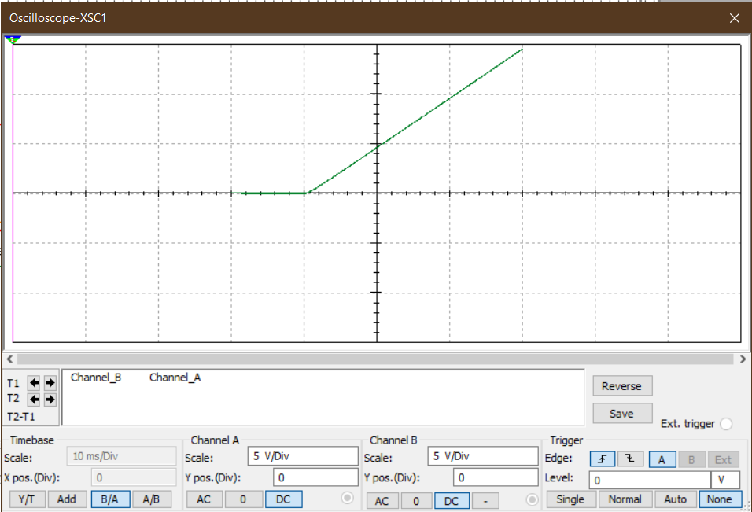

***Graph 1.4:*** *Transfer function curve for biased series clipper circuit.*

1. **Biased parallel clipper circuit:**

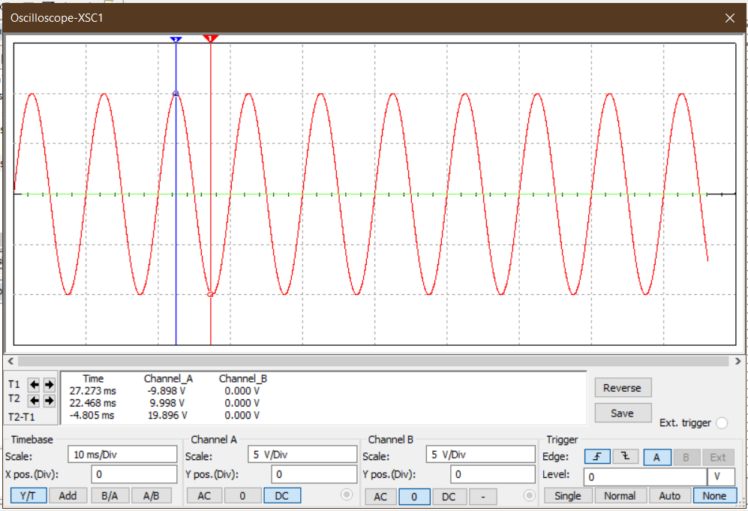

***Graph 1.5:*** *Input signal for biased parallel clipper circuit.*

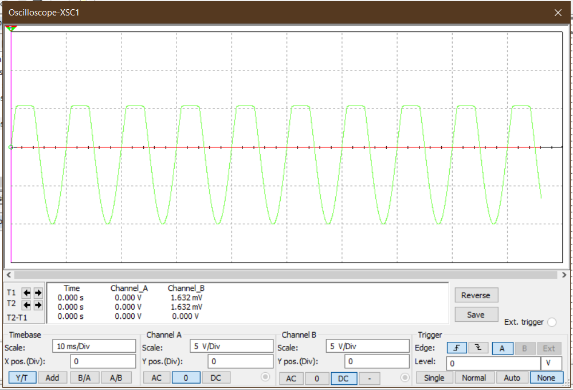

***Graph 1.6:*** *Output signal for biased parallel clipper circuit.*

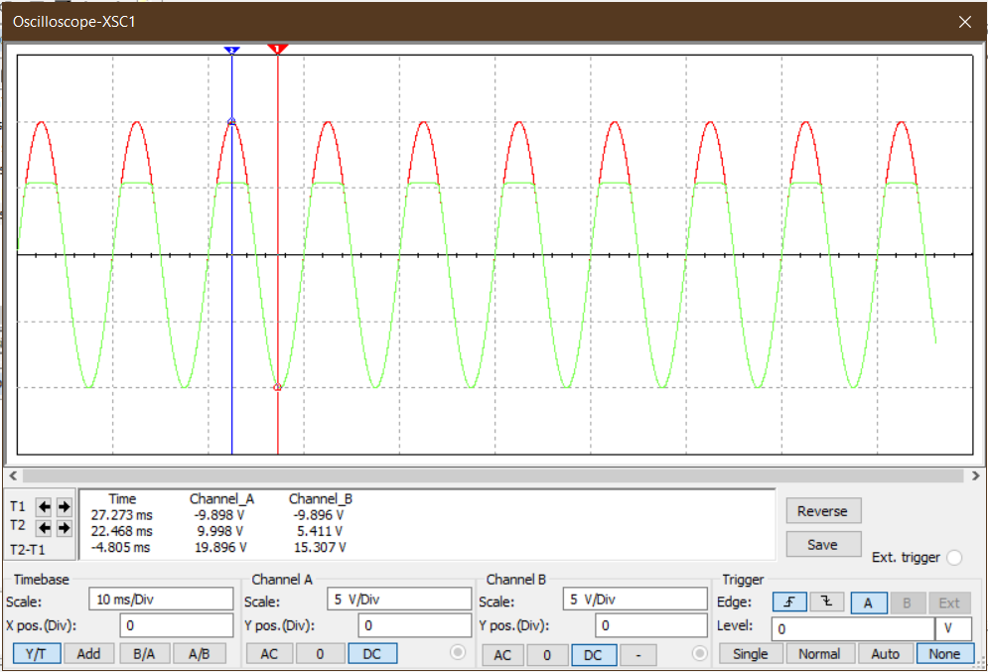

***Graph 1.7:*** *Input and output signal for biased parallel clipper circuit.*

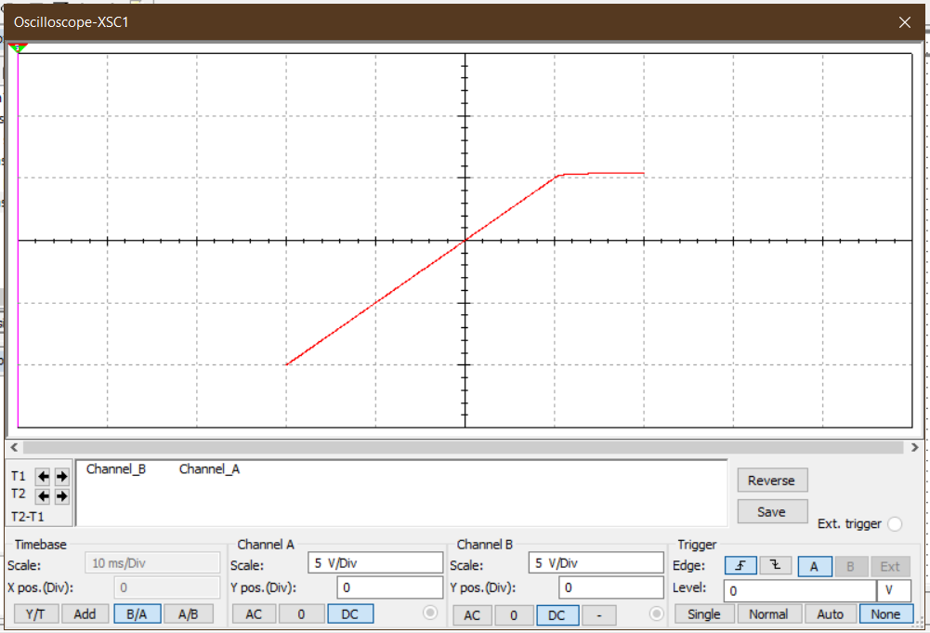

***Graph 1.8:*** *Transfer function curve for biased parallel clipper circuit.*

**Result:**

For a biased series clipper circuit, positive half cycle output was around 14.3V, and for negative half cycle, output was completely clipped off.

For a biased parallel clipper circuit, positive half cycle output was around 5.7V and for negative half cycle, output was 10V.

**Conclusion:**

For a biased series clipper circuit, the AC input signal shifts its origin for the DC voltage. Here, for the positive half cycle, output magnitude was around 14.3V as 0.7V was dropped across the diode. But for the negative half cycle, the output signal was completely clipped off as the diode was in forwarding bias condition. This is because the voltage measured is across the load resistor.

For a biased parallel clipper circuit, the graphical output resembles a negative half-wave rectifier. It is because the voltage is measured across the diode, rather than a load resistor. When the diode is in forward bias, the only voltage measured in the positive portions of the wave is the 5V DC voltage plus the diode voltage which is 0.7V when forward biased. But for the negative half cycle, the diode was open-circuited resulting in an open circuit situation. As a result, the negative magnitude was 10V.

*Heaven’s light is our guide.*

**Rajshahi University of Engineering and Technology**

**(RUET)**

**Department of Electrical & Electronic Engineering**

**Course no.** EEE2204

**Course title:** Electronics III Sessional

**Experiment no.** 02

# **Experiment name:** Experimental study of a clamper circuit using passive elements.

**Submitted to:**

**Dr. Md. Samiul Habib**

Associate Professor

Dept. of Electrical & Electronic Engineering,

Rajshahi University of Engineering and Technology.

**Submitted by:**

**Ashraf Al- Khalique**

**Roll:** 1801171; **Session:** 2018-2019

Dept. of Electrical & Electronic Engineering,

Rajshahi University of Engineering and Technology.

**Date of experiment:** January 28, 2021.

**Date of submission:** February 04, 2021.

**Experiment no**. 02

**Name of the Experiment:** Experimental study of a clamper circuit using passive elements.

**Objectives:** Followings are the main objectives of this experiment,

1. To understand the theory of operation of the clamper circuit using passive elements.
2. To study the diode applications in a clamper circuit using passive elements.
3. To observe wave shapes that meet the clamper circuit’s needs.

**List of Components:**

1. Function Generator (-10V- 10V;0.5msec- 1msec)
2. DC power supply (5V)
3. Resistors (151kΩ; 1 piece)
4. Diode (1N 4007; 1 piece)
5. Oscilloscope
6. Project board
7. Capacitor (1µF; 1 piece)
8. Connecting wires
9. Simulator (Multisim 11.0)

**Circuit diagram:**



***Fig 1.1:*** *Circuit diagram for Biased* *positive clamper circuit.*

**

***Fig 1.2:*** *Circuit diagram for Biased* *negative clamper circuit.*

**Waveshape:**

1. **Biased positive clamper circuit:**

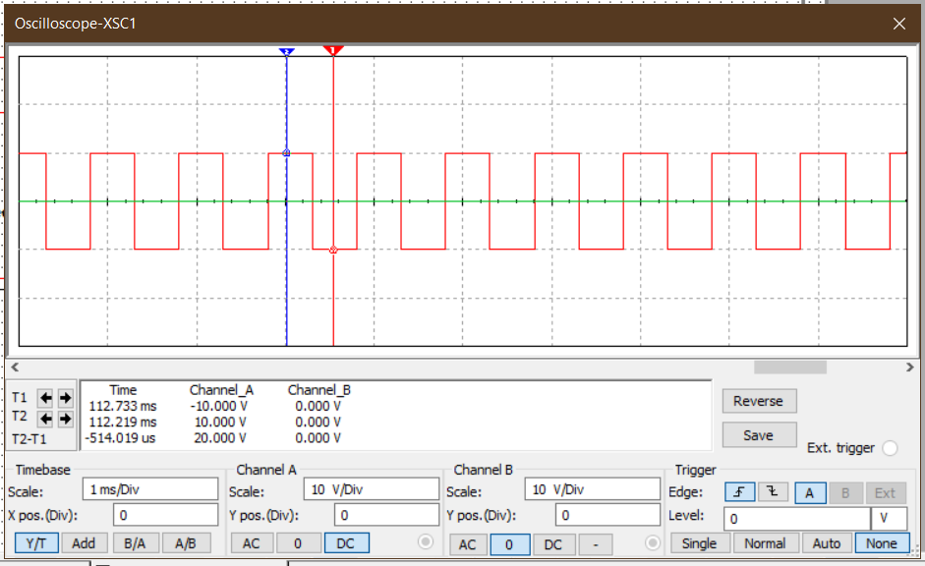

***Graph 1.1:*** *Input signal for biased positive clamper circuit.*

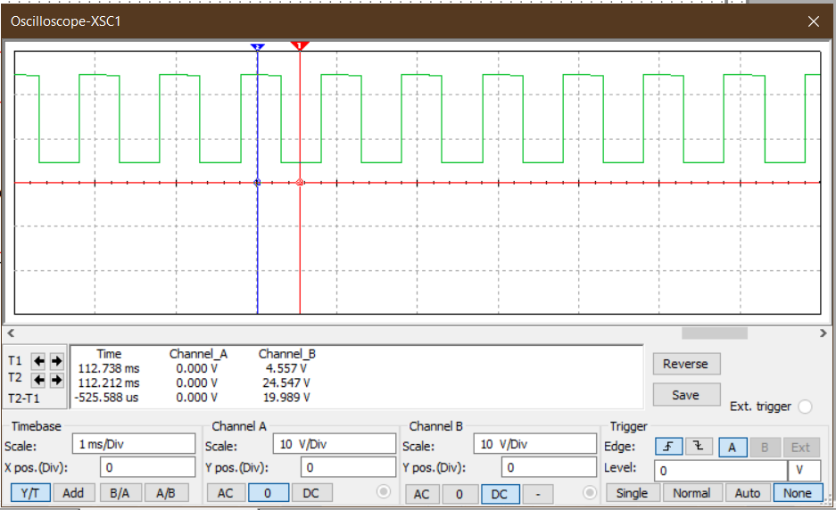

***Graph 1.2:*** *Output signal for biased positive clamper circuit.*

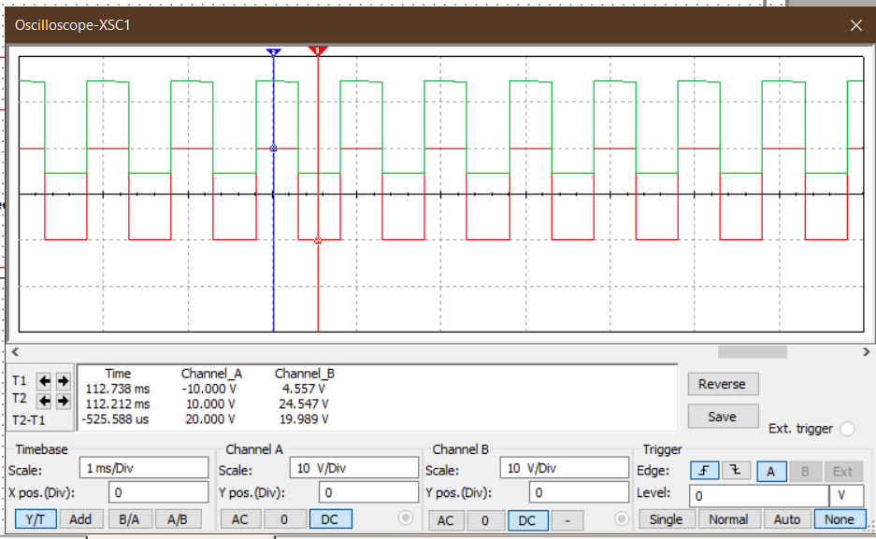

***Graph 1.3:*** *Input and output signal for biased positive clamper circuit.*

1. **Biased negative clamper circuit:**

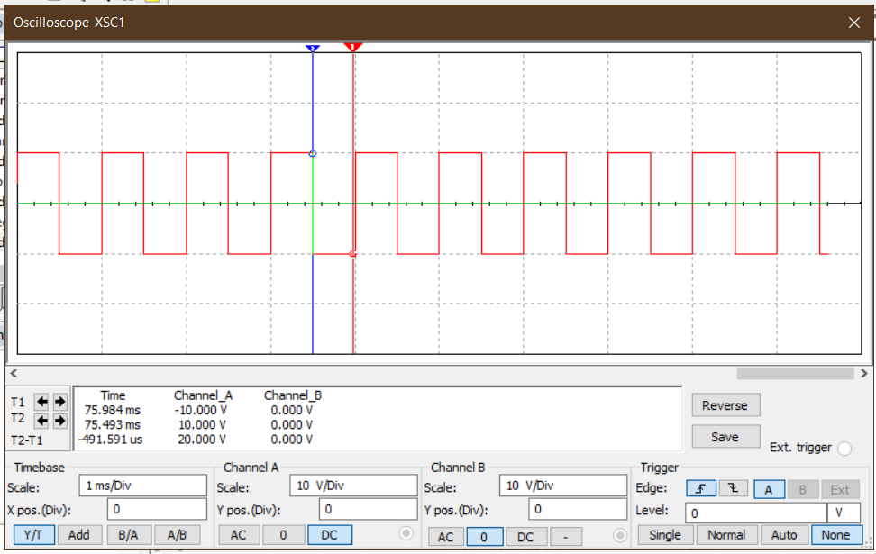

***Graph 2.1:*** *Input signal for biased negative clamper circuit.*

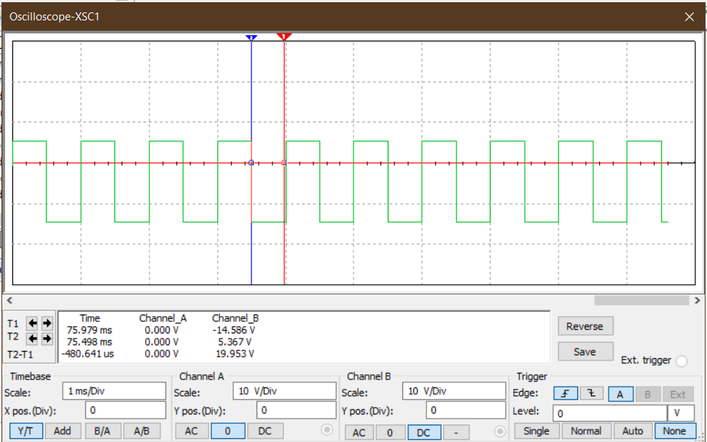

***Graph 2.2:*** *Output signal for biased negative clamper circuit.*

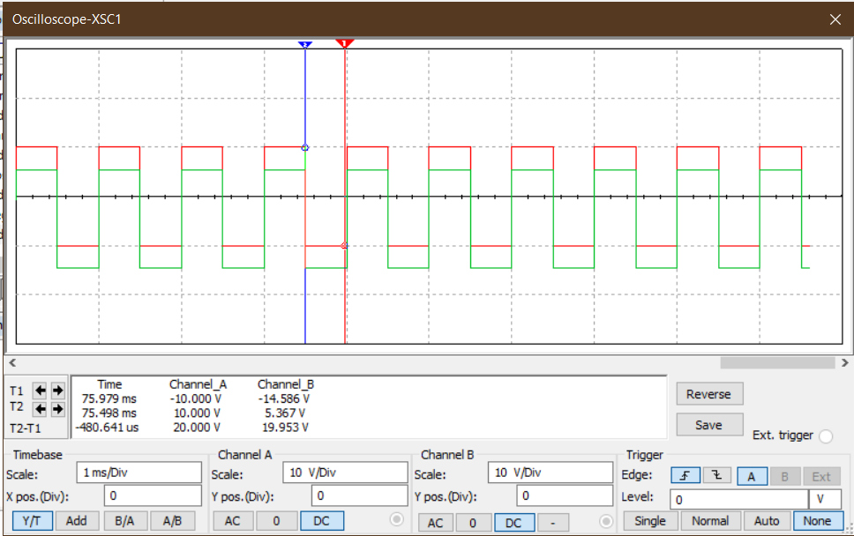

***Graph 2.3:*** *Input and output signal for biased negative clamper circuit.*

**Result:**

For a biased positive clamper circuit, positive half cycle output was around 24.5V, and for negative half cycle, output was 4.5V.

For a biased negative clamper circuit, positive half cycle output was around 5.3V, and for negative half cycle, output was -14.58V.

**Conclusion:**

For a biased positive clamper circuit, in the positive half cycle, the diode was c. Therefore, 24.5V was measured due to the diode being open. But for the negative half cycle, the diode was in conduction mode. So, the output was around 4.54V with around 0.45V drop across the diode.

For a biased negative clamper circuit, for a positive half cycle, the diode was in conduction mode. So, the output was 5.370V with a slight voltage drop across the diode and a DC source of 5V. For the negative half cycle, the diode was 5.370V meaning an open circuit. So output was stored voltage in the capacitor. So, the amplitude was -14.582V

*Heaven’s light is our guide.*

**Rajshahi University of Engineering and Technology**

**(RUET)**

**Department of Electrical & Electronic Engineering**

**Course no.** EEE2204

**Course title:** Electronics III Sessional

**Experiment no.** 03

# **Experiment name:** Experimental study of precision half wave and full wave rectifier circuits using Op-Amp.

**Submitted to:**

**Dr. Md. Samiul Habib**

Associate Professor

Dept. of Electrical & Electronic Engineering,

Rajshahi University of Engineering and Technology.

**Submitted by:**

**Ashraf Al- Khalique**

**Roll:** 1801171; **Session:** 2018-2019

Dept. of Electrical & Electronic Engineering,

Rajshahi University of Engineering and Technology.

**Date of experiment:** March 10, 2021.

**Date of submission:** March 25, 2021.

**Experiment no**. 03

**Name of the Experiment:** Experimental study of precision half wave and full wave rectifier circuits using Op-Amp.

**Objectives:** Followings are the main objectives of this experiment,

1. To understand the theory of operation of precision half wave and full wave rectifier circuits.
2. To study the diode applications in precision half wave and full wave rectifier circuits.
3. To observe wave shapes that meet the precision half wave and full wave rectifier circuits’ needs.

**List of Components:**

1. Function Generator
2. DC power supply (61mV)
3. Resistors (1kΩ; 4 pieces)
4. Op- Amp (µA741; 2 pieces)
5. Diode (1N 4007; 2 pieces)
6. Oscilloscope
7. Project board
8. Connecting wires
9. Simulator (Multisim 11.0)

**Circuit diagram:**



***Fig 1.1:*** *Circuit diagram for precision half wave rectifier circuits using Op-Amp.*

**

***Fig 1.2:*** *Circuit diagram for precision full wave rectifier circuits using Op-Amp.*

**Waveshape:**

1. **Precision half wave rectifier circuits using Op-Amp:**

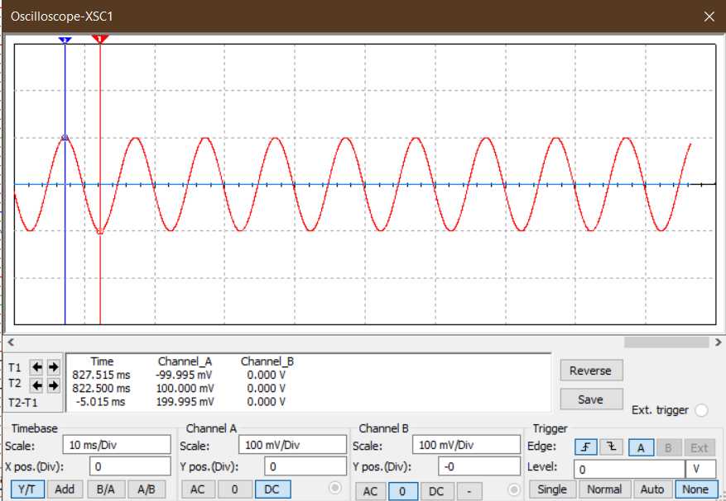

***Graph 1.1:*** *Input signal for* *precision half wave rectifier circuits using Op-Amp.*

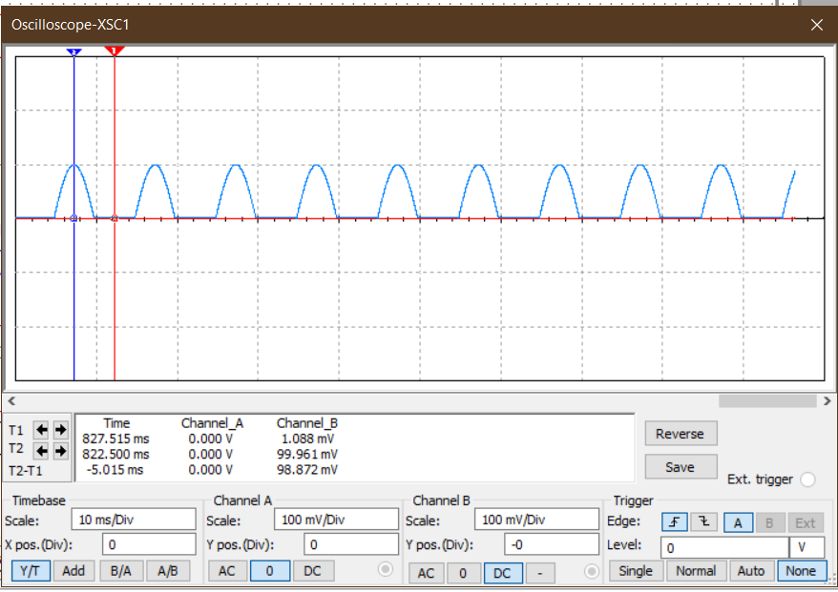

***Graph 1.2:*** *Output signal for precision half wave rectifier circuits using Op-Amp.*

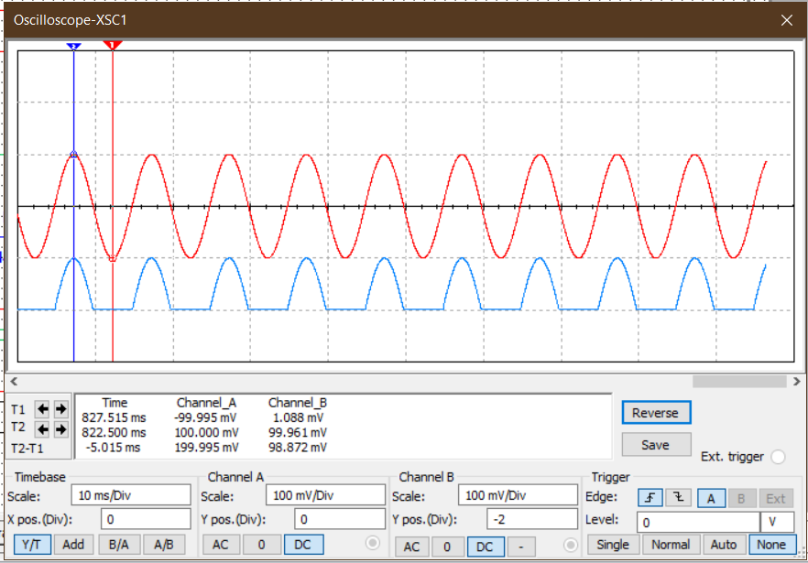

***Graph 1.3:*** *Input and output signal for precision half wave rectifier circuits using Op-Amp.*

1. **Precision full wave rectifier circuits using Op-Amp:**

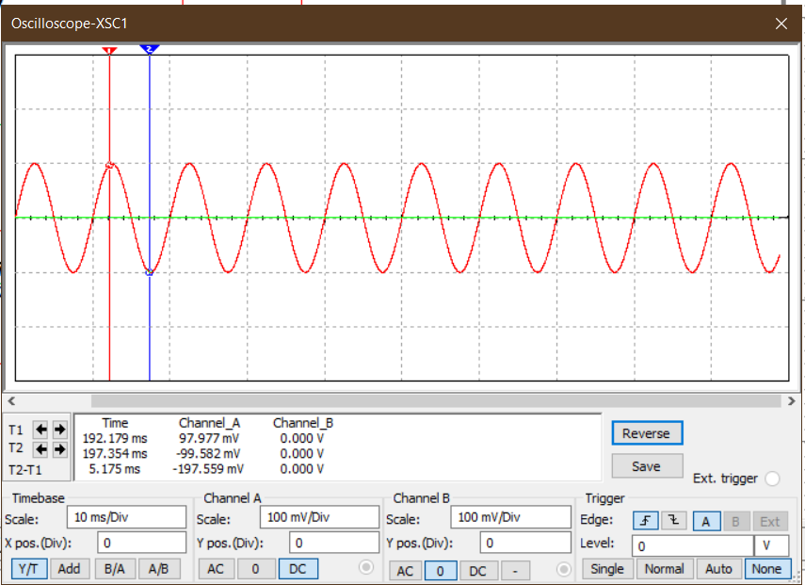

***Graph 2.1:*** *Input signal for precision full wave rectifier circuits using Op-Amp.*

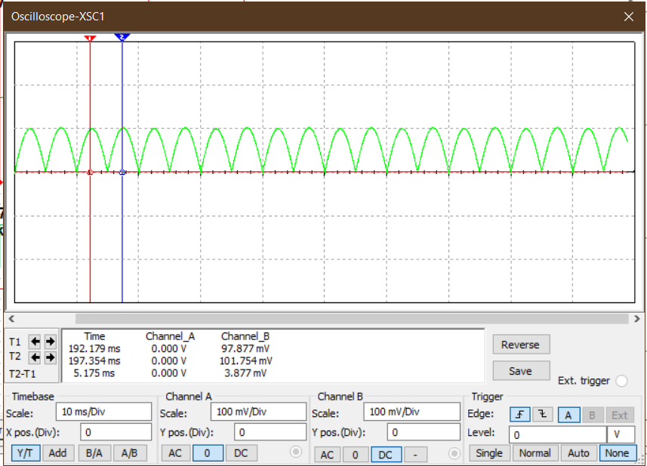

***Graph 2.2:*** *Output signal for precision full wave rectifier circuits using Op-Amp.*

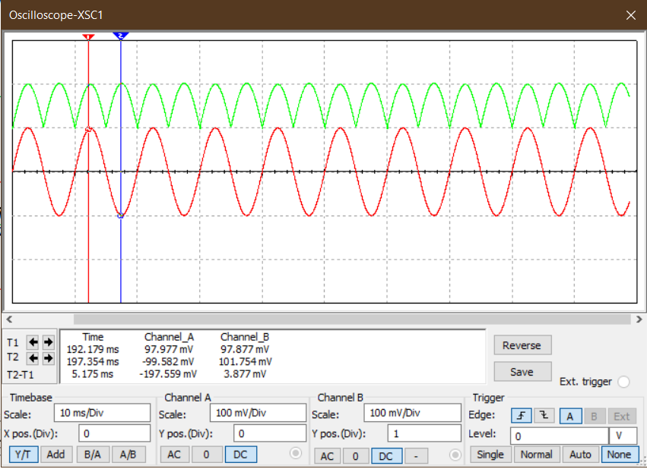

***Graph 2.3:*** *Input and output signal for precision full wave rectifier circuits using Op-Amp.*

**Result:**

In precision half wave rectifier circuit, in positive half cycle, output was almost equal to input but negative half cycle was completely clipped.

In precision full wave rectifier circuit, negative half cycle was inverted and was same as positive half cycle.

**Conclusion:**

For both precision half wave and full wave rectifier circuit, the desired output signal was obtained when large input signal was given.

In case of precision half wave rectifier circuit, R1, R2, R3 and R4 were equal in value. For positive half cycle, D2 was short circuited. Therefore, Vout is equal to Vin. On the other hand, for negative half cycle, D2 was open and D1 was short circuited. Vout becomes zero.

In case of precision full wave rectifier circuit, R1, R2, R3, R6, R7 were equal in value and R4 and R5 were double their value. For positive half cycle, D2 was short. So, source voltage and output of the first op-amp, both worked as an adder circuit where R5 was feedback for second op-amp. The output of this adder is equal to Vin. On the other hand, for negative half cycle, D2 was open. Vout was just inverted.

*Heaven’s light is our guide.*

**Rajshahi University of Engineering and Technology**

**(RUET)**

**Department of Electrical & Electronic Engineering**

**Course no.** EEE2204

**Course title:** Electronics III Sessional

**Experiment no.** 04

# **Experiment name:** Experimental study of a comparator and a Zero crossing detector circuit using Op-Amp.

**Submitted to:**

**Dr. Md. Samiul Habib**

Associate Professor

Dept. of Electrical & Electronic Engineering,

Rajshahi University of Engineering and Technology.

**Submitted by:**

**Ashraf Al- Khalique**

**Roll:** 1801171; **Session:** 2018-2019

Dept. of Electrical & Electronic Engineering,

Rajshahi University of Engineering and Technology.

**Date of experiment:** March 18, 2021.

**Date of submission:** March 24, 2021.

**Experiment no**. 04

**Name of the Experiment:** Experimental study of a comparator and a Zero crossing detector circuit using Op-Amp.

**Objectives:** Followings are the main objectives of this experiment,

1. To understand the theory of operation of a comparator and a Zero crossing detector circuit.
2. To study the Op-Amp applications in a comparator and a Zero crossing detector circuit.
3. To observe wave shapes that meet a comparator and a Zero crossing detector circuits’ needs.

**List of Components:**

1. Function Generator
2. DC power supply (61mV)
3. Resistors (1kΩ; 1 piece)
4. Op-Amp (µA741; 1 piece)
5. Oscilloscope
6. Project board
7. Connecting wires
8. Simulator (Multisim 11.0)

**Circuit diagram:**



***Fig 1.1:*** *Circuit diagram for a* *comparator circuit using Op-Amp.*

**

***Fig 1.2:*** *Circuit diagram for* *zero-crossing detector circuits using Op-Amp.*

**Waveshape:**

1. **Comparator circuit using Op-Amp:**

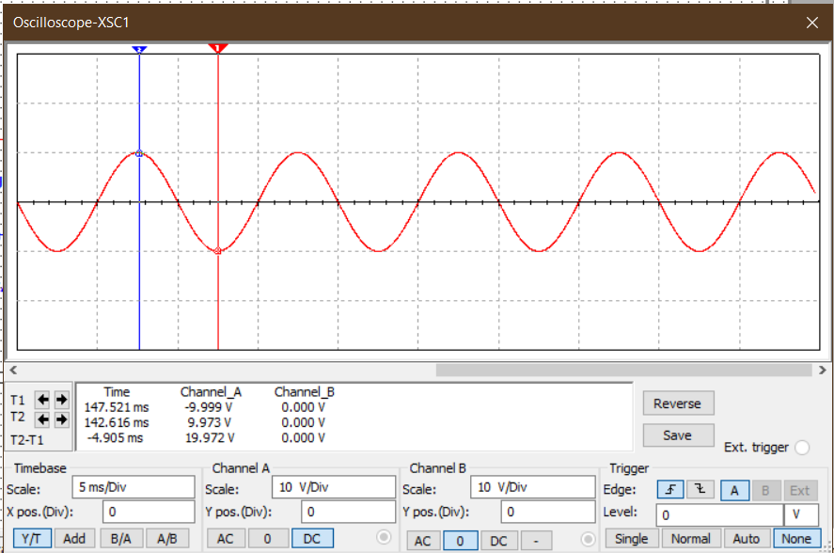

***Graph 1.1:*** *Input signal for a comparator circuit using Op-Amp.*

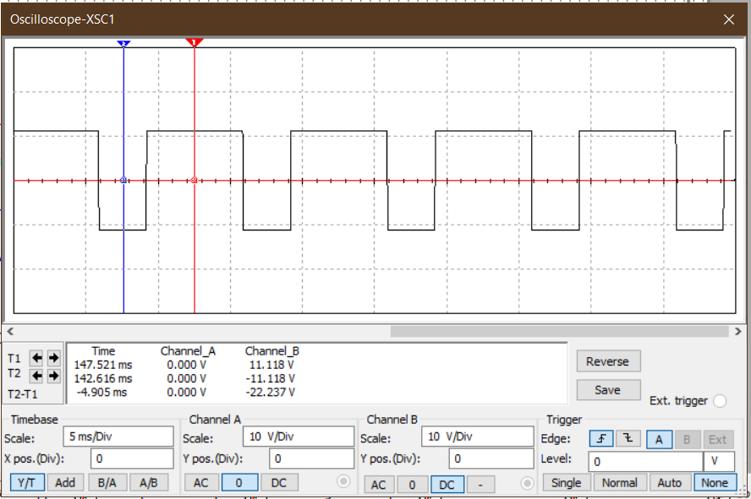

***Graph 1.2:*** *Output signal for a comparator circuit using Op-Amp.*

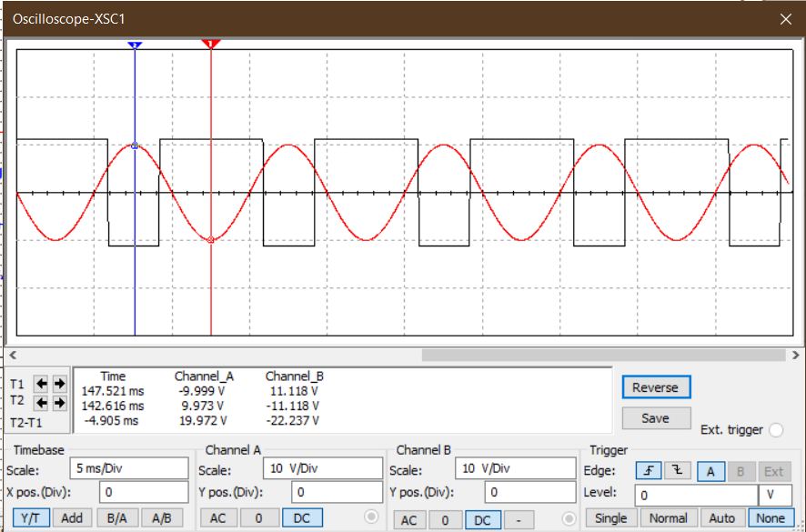

***Graph 1.3:*** *Input and output signal for a comparator circuit using Op-Amp.*

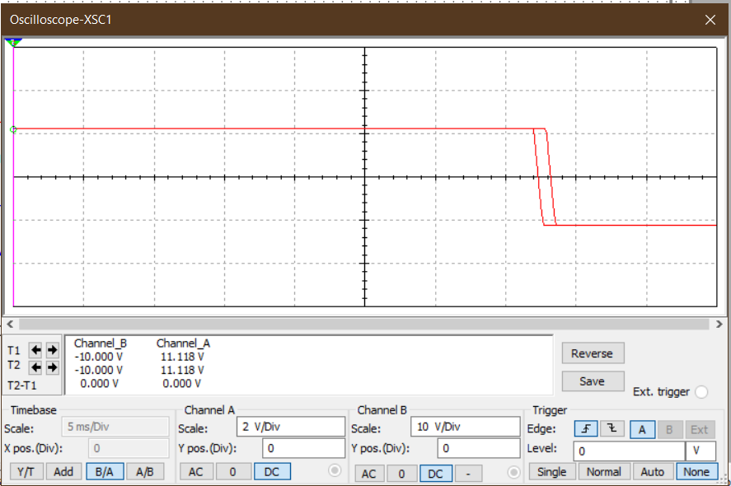

***Graph 1.4:*** *Transfer characteristics for a comparator circuit using Op-Amp.*

1. **Zero crossing detector circuits using Op-Amp:**

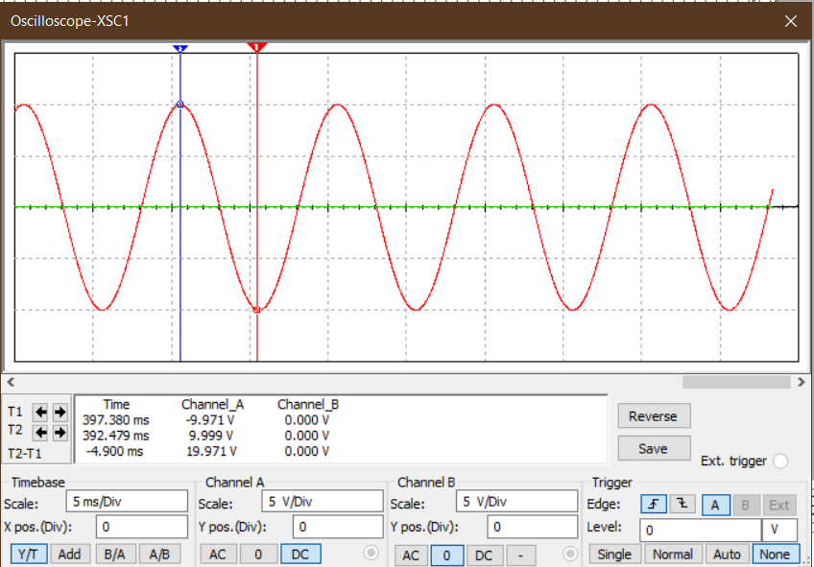

***Graph 2.1:*** *Input signal for zero-crossing detector circuits using Op-Amp.*

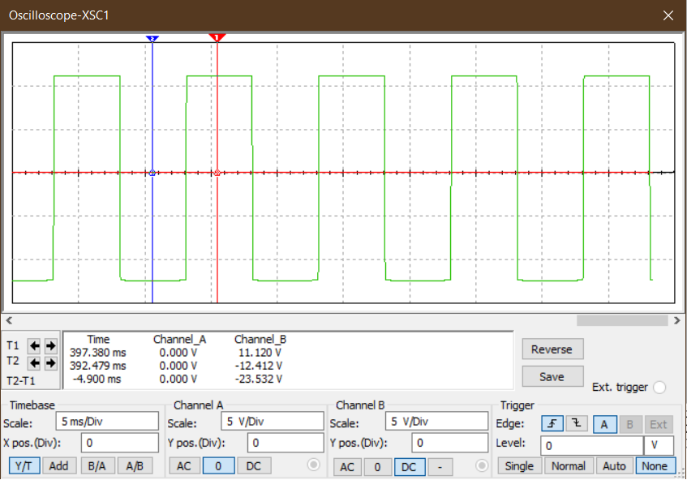

***Graph 2.2:*** *Output signal for zero-crossing detector circuit using Op-Amp.*

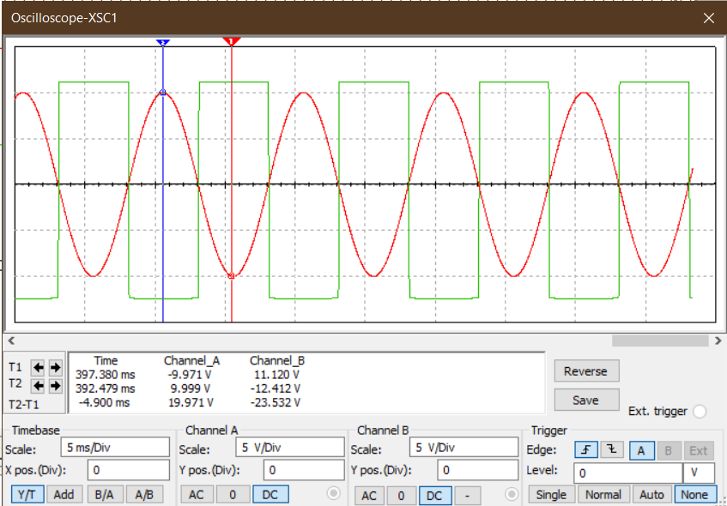

***Graph 2.3:*** *Input and output signal for zero-crossing detector circuits using Op-Amp.*

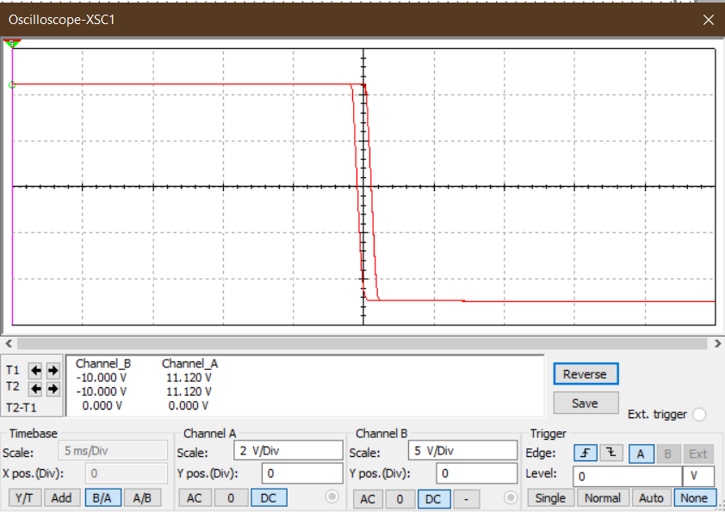

***Graph 2.4:*** *Transfer characteristics for a zero-crossing detector circuit using Op-Amp.*

**Result:**

In comparator circuit, for input sinusoidal signal, a digital signal with a positive peak of +Vcc and negative peak of –Vcc which intercepted the positive half cycle of input voltage at a reference voltage of 4.8V was found at the output.

In zero-crossing detector circuit, for input sinusoidal signal, a digital signal with –Vcc and +Vcc peaks which crossed the input signal at zero voltage was obtained at the output.

**Conclusion:**

For a comparator circuit, when input voltage was greater than reference voltage, Vout was +Vsat. But when input voltage was less than reference voltage, Vout was -Vsat. Here If we want the output signal to be removed completely, we just need to ground –Vcc. We can also make the shape of the negative half cycle thinner by increasing the value of comparator.

For a Zero Crossing detector circuit, the reference voltage used in comparator is grounded. So, transition occurs whenever the input changes from positive to negative or when input becomes zero(momentarily). Thus, if there are noises included with the input signal, there are some unwanted zero inputs as well. This will do unwanted transitions in output signal as well. This can be removed by using Schmitt Trigger.

*Heaven’s light is our guide.*

**Rajshahi University of Engineering and Technology**

**(RUET)**

**Department of Electrical & Electronic Engineering**

**Course no.** EEE2204

**Course title:** Electronics III Sessional

**Experiment no.** 05

# **Experiment name:** Experimental study of an inverting Schimitt Trigger using Op-Amp.

**Submitted to:**

**Dr. Md. Samiul Habib**

Associate Professor

Dept. of Electrical & Electronic Engineering,

Rajshahi University of Engineering and Technology.

**Submitted by:**

**Ashraf Al- Khalique**

**Roll:** 1801171; **Session:** 2018-2019

Dept. of Electrical & Electronic Engineering,

Rajshahi University of Engineering and Technology.

**Date of experiment:** March 24, 2021.

**Date of submission:** March 30, 2021.

**Experiment no**. 05

**Name of the Experiment:** Experimental study of an inverting Schmitt trigger using Op-Amp.

**Objectives:** Followings are the main objectives of this experiment,

1. To understand the theory of operation of an inverting Schmitt trigger circuit.
2. To study the Op-Amp applications in a Schmitt trigger circuit.
3. To observe wave shapes that meet a Schmitt trigger circuits’ need.

**List of Components:**

1. Function Generator
2. DC power supply (10V)
3. Resistors (51kΩ; 2 pieces)
4. Op-Amp (µA741; 1 piece)
5. Oscilloscope
6. Project board
7. Connecting wires
8. Simulator (Multisim 11.0)

**Circuit diagram:**



***Fig 1.2:*** *Circuit diagram for an inverting Schmitt trigger using Op-Amp.*

**Waveshape:**

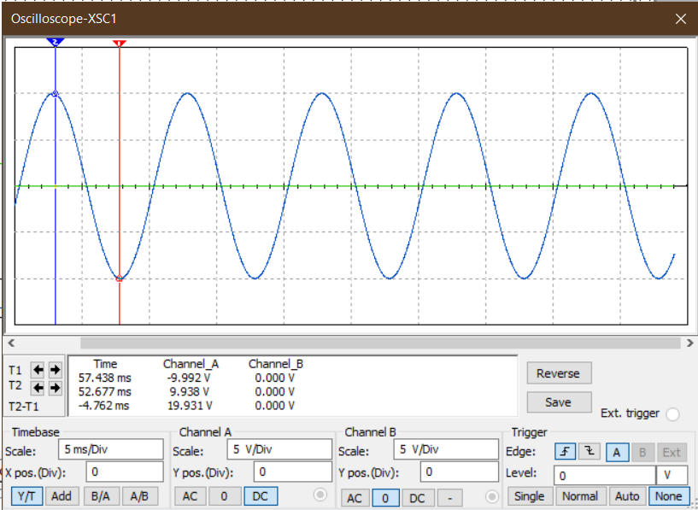

***Graph 1.1:*** *Input signal for an inverting Schmitt Trigger circuit using Op-Amp.*

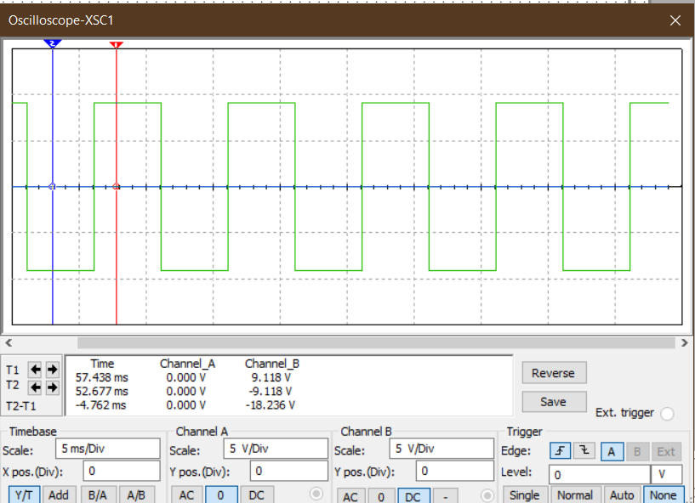

***Graph 1.2:*** *Output signal for an inverting Schmitt Trigger circuit using Op-Amp.*

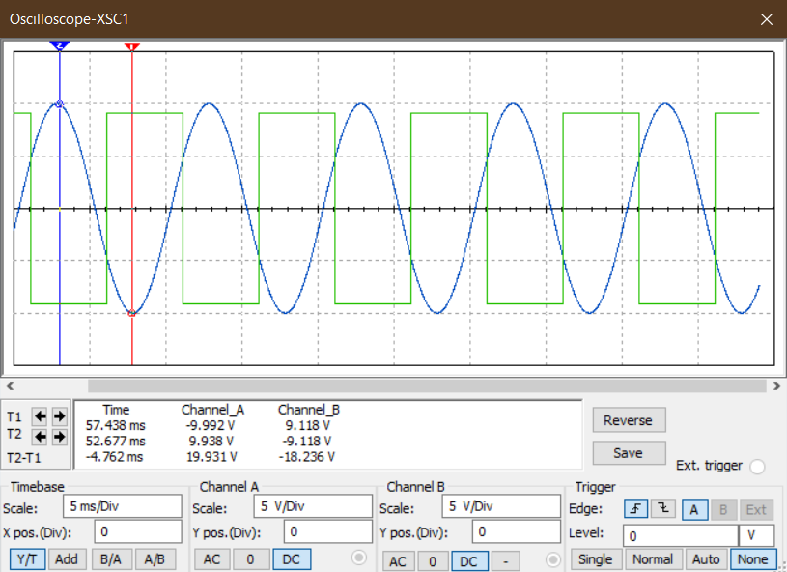

***Graph 1.1:*** *Input & Output signal for an inverting Schmitt Trigger circuit using Op-Amp.*

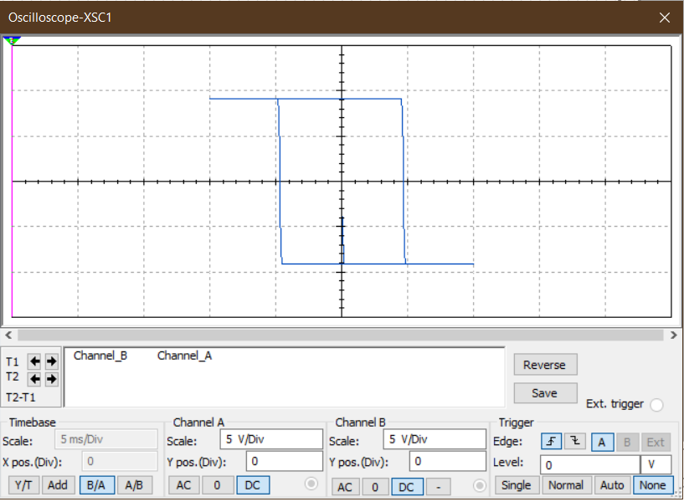

***Graph 1.1:*** *Transfer characteristics for an inverting Schmitt Trigger circuit using Op-Amp.*

**Result:**

In this Schmitt trigger circuit, for input sinusoidal signal, a digital signal with –Vcc and +Vcc peaks which crossed the reference voltage was obtained at the output.

**Conclusion:**

In this experiment, reference voltage is known as threshold voltage which is 10V in this case. Here Vin is less than upper threshold voltage and as there is a feedback connection between non-inverting terminal and output terminal, Vin triggers the Vout in +Vcc every time its lower than this upper threshold voltage.

Reverse situation occurs, when Vin is less than lower threshold voltage, Vin triggers the Vout in

-Vcc every time its higher than this upper threshold voltage This is why Vin changes Vout every time when it exceeds threshold voltage.

As a result, this circuit design eliminates the false transition with the help of threshold voltage.

*Heaven’s light is our guide.*

**Rajshahi University of Engineering and Technology**

**(RUET)**

**Department of Electrical & Electronic Engineering**

**Course no.** EEE2204

**Course title:** Electronics III Sessional

**Experiment no.** 06

# **Experiment name:** Experimental study of a monostable multivibrator using 555 timer.

**Submitted to:**

**Dr. Md. Samiul Habib**

Associate Professor

Dept. of Electrical & Electronic Engineering,

Rajshahi University of Engineering and Technology.

**Submitted by:**

**Ashraf Al- Khalique**

**Roll:** 1801171; **Session:** 2018-2019

Dept. of Electrical & Electronic Engineering,

Rajshahi University of Engineering and Technology.

**Date of experiment:** August 5, 2021.

**Date of submission:** November 20, 2021.

**Experiment no**. 06

**Name of the Experiment:** Experimental study of a monostable multivibrator using 555- timer.

**Objectives:** Followings are the main objectives of this experiment,

1. To understand the theory of operation of a monostable multivibrator using 555- timer.
2. To study the 555- timer applications in a monostable multivibrator.
3. To observe wave shapes that meet a monostable multivibrator using 555- timers’ need.

**List of Components:**

1. Function Generator
2. DC power supply (10V)
3. Capacitor (0.1µF, 0.01µF; 1 piece each)
4. Resistor (45.5kΩ; 1piece)
5. 555- timer (1 piece)
6. Oscilloscope
7. Project board
8. Connecting wires
9. Simulator (Multisim 11.0)

**Circuit diagram:**



***Fig 1.2:*** *Circuit diagram for a monostable multivibrator using 555- timer.*

**Waveshape:**

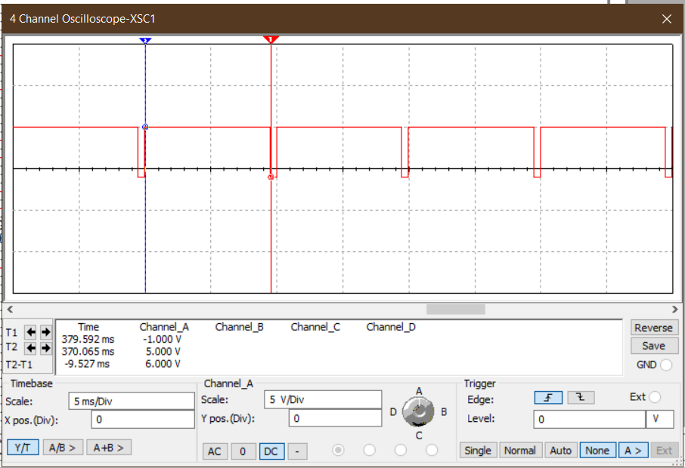

***Graph 1.1:*** *Triggering/Input signal for a monostable multivibrator using 555- timer.*

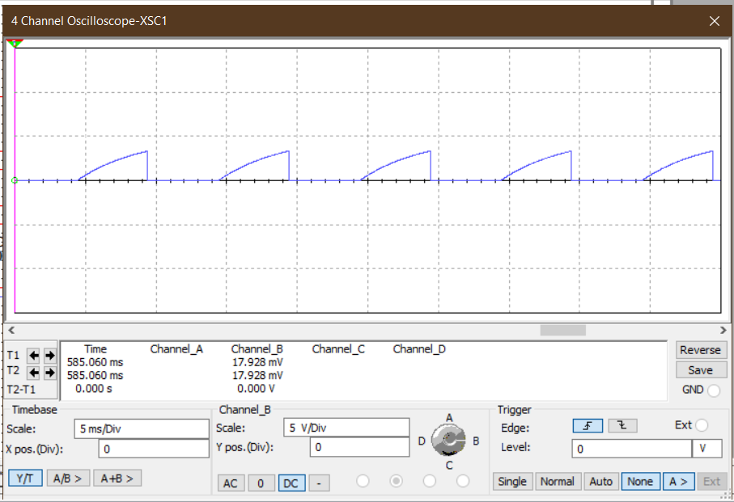

***Graph 1.2:*** *Capacitor voltage signal for a monostable multivibrator using 555- timer.*

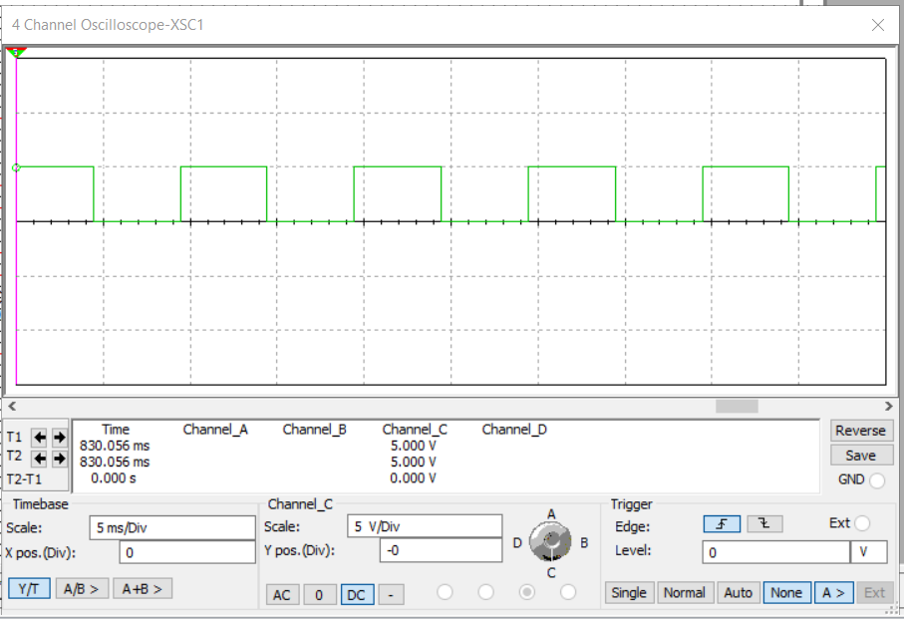

***Graph 1.3:*** *Output signal for a monostable multivibrator using 555- timer.*

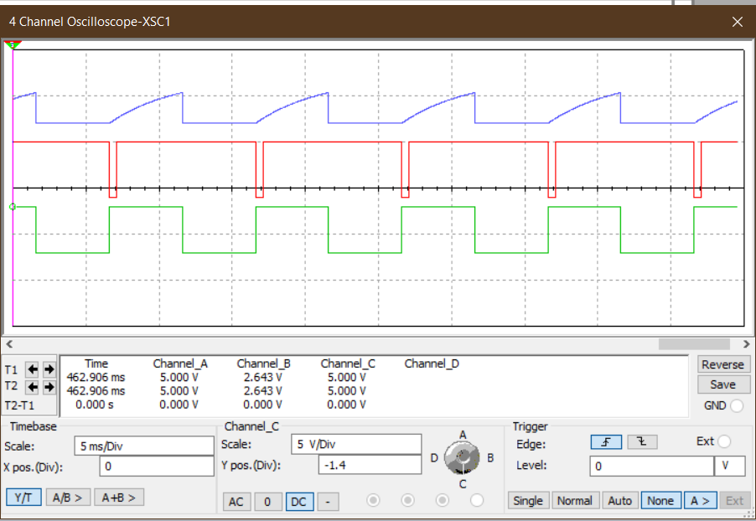

***Graph 1.4:*** *Triggering, capacitor voltage & Output signal for a monostable multivibrator using 555- timer.*

**Result:**

Here, whenever the input signal reaches negative pulse, output signal goes into positive peak, +Vcc. Again, whenever the capacitor voltage exceeds two third value of +Vcc, output signal reduces to zero. The time period of this high state was 5msec where input signal period was 10msec.

**Conclusion:**

In this experiment, the monostable multivibrator has only stable logic low state. When a negative pulse was applied as triggering, the output level got stable logic high state which was +Vcc. The external resistance and capacitance were set according to [$t=1.1×R1×C1$] where ‘t’ is the time period of capacitor voltage rising.

Here, capacitor voltage got to the level of two-third of +Vcc at the time period. After two third voltage level of +Vcc, the output returned to the stable logic low state. This state remained till the next negative pulse is reached. Thus, during half of the total time period, output was logic high, and at another half period, that was logic low. So, the actual output wave was a square wave shaping.

So, we can generate a square wave shape by using a 555 timer and connecting as a monostable multivibrator.

*Heaven’s light is our guide.*

**Rajshahi University of Engineering and Technology**

**(RUET)**

**Department of Electrical & Electronic Engineering**

**Course no.** EEE2204

**Course title:** Electronics III Sessional

**Experiment no.** 07

# **Experiment name:** Experimental study of an astable multivibrator using 555 timer.

**Submitted to:**

**Dr. Md. Samiul Habib**

Associate Professor

Dept. of Electrical & Electronic Engineering,

Rajshahi University of Engineering and Technology.

**Submitted by:**

**Ashraf Al- Khalique**

**Roll:** 1801171; **Session:** 2018-2019

Dept. of Electrical & Electronic Engineering,

Rajshahi University of Engineering and Technology.

**Date of experiment:** August 5, 2021.

**Date of submission:** November 20, 2021.

**Experiment no**. 07

**Name of the Experiment:** Experimental study of an astable multivibrator using 555- timer.

**Objectives:** Followings are the main objectives of this experiment,

1. To understand the theory of operation of an astable multivibrator using 555- timer.
2. To study the 555- timer applications in an astable multivibrator.
3. To observe wave shapes that meet an astable multivibrator using 555- timers’ need.

**List of Components:**

1. Function Generator
2. DC power supply (10V)
3. Resistor (10kΩ, 5kΩ; 1piece each)
4. Capacitor (0.1µF, 0.01µF; 1 piece each)
5. 555- timer (1 piece)
6. Oscilloscope
7. Project board
8. Connecting wires
9. Simulator (Multisim 11.0)

**Circuit diagram:**



***Fig 1.2:*** *Circuit diagram for an astable multivibrator using 555- timer.*

**Waveshape:**

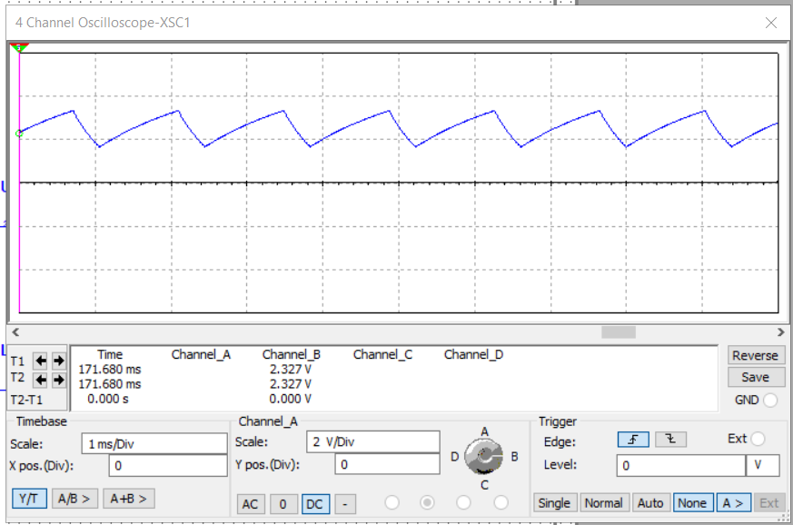

***Graph 1.2:*** *Capacitor voltage signal for an astable multivibrator using 555- timer.*

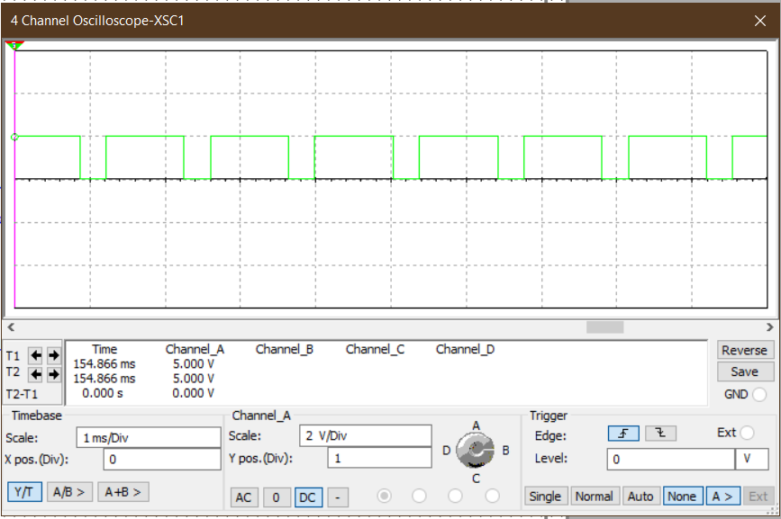

***Graph 1.3:*** *Output signal for an astable multivibrator using 555- timer.*

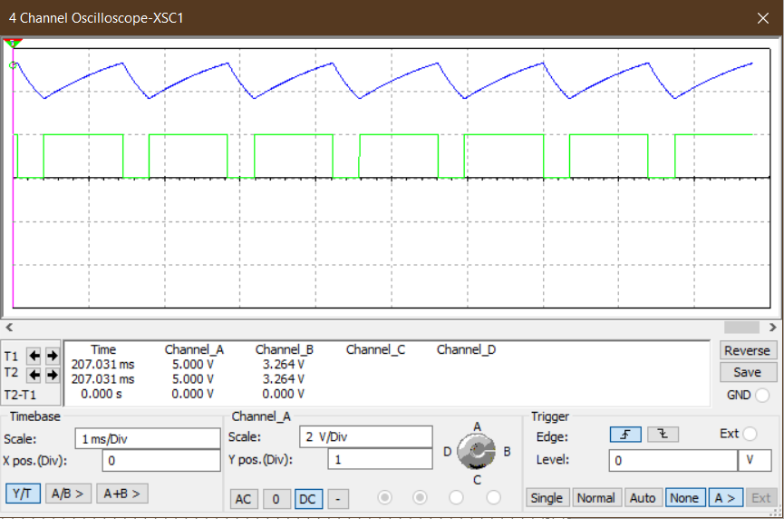

***Graph 1.4:*** *Capacitor voltage & Output signal for an astable multivibrator using 555- timer.*

**Result:**

Here, in this experiment, an astable multivibrator is used. This can generate both rectangular and square wave without any external triggering. Here, the logic high depends on the capacitor charging time period while the logic low depends on discharging.

**Conclusion:**

In this experiment, when output was at logic high, the capacitor started to be charged through resistance R1 and R2. So, the charging period was,

tc=0.69*C1*(R1+R2)

During this period of the capacitor being charged, output remained to be at a logic high. When the capacitor was charged to two-third of +Vcc, it started to discharge through only R2. So, this discharging period was,

td=0.69*C1*R2

In this period output became logic low. So, the output was a rectangular wave with a time period of,

T= tc+td

If we want a square wave to be produced by an astable multivibrator, then we have to make ‘R1=R2’ and add a diode parallel to R2.

*Heaven’s light is our guide.*

**Rajshahi University of Engineering and Technology**

**(RUET)**

**Department of Electrical & Electronic Engineering**

**Course no.** EEE2204

**Course title:** Electronics III Sessional

**Experiment no.** 08

# **Experiment name:** Experimental study of a FSK generator using 555 timer.

**Submitted to:**

**Dr. Md. Samiul Habib**

Associate Professor

Dept. of Electrical & Electronic Engineering,

Rajshahi University of Engineering and Technology.

**Submitted by:**

**Ashraf Al- Khalique**

**Roll:** 1801171; **Session:** 2018-2019

Dept. of Electrical & Electronic Engineering,

Rajshahi University of Engineering and Technology.

**Date of experiment:** August 5, 2021.

**Date of submission:** November 20, 2021.

**Experiment no**. 08

**Name of the Experiment:** Experimental study of a FSK generator using 555- timer.

**Objectives:** Followings are the main objectives of this experiment,

1. To understand the theory of operation of a FSK generator using 555- timer.
2. To study the 555- timer applications in a FSK generator.
3. To observe wave shapes that meet a FSK generator using 555- timers’ need.

**List of Components:**

1. Function Generator
2. DC power supply
3. Potentiometer (50kΩ- 2piece, 40kΩ- 1 piece)
4. Capacitor (0.01µF, 0.01µF; 1 piece each)
5. 555- timer (1 piece)
6. NPN BJT (1 piece)
7. Oscilloscope
8. Project board
9. Connecting wires
10. Simulator (Multisim 11.0)

**Circuit diagram:**



***Fig 1.2:*** *Circuit diagram for a FSK generator using 555- timer.*

**Waveshape:**

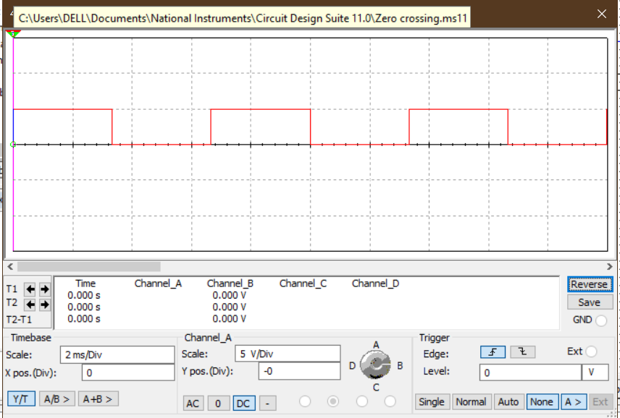***Graph 1.2:*** *Capacitor voltage signal for a FSK generator using 555- timer.*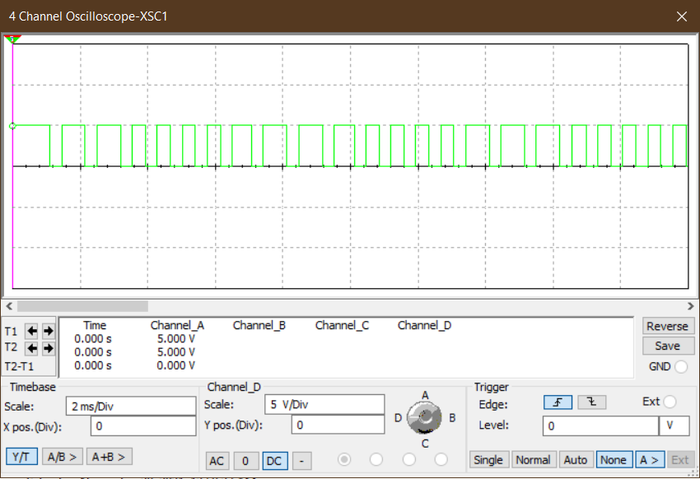

***Graph 1.3:*** *Output signal for a FSK generator using 555- timer.*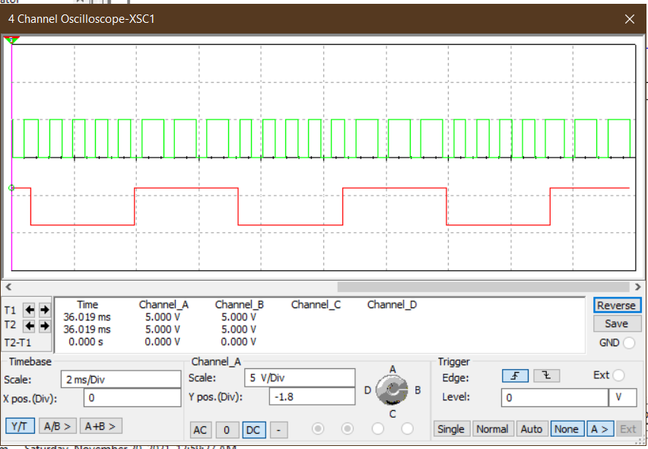

***Graph 1.4:*** *Input & Output signal for a FSK generator using 555- timer.*

**Result:**

In this experiment, at the logic high of input signal, output signal has a higher frequency than input frequency with lower time period.

At the logic low of input signal, output signal has a lower frequency than input frequency with higher time period.

**Conclusion:**

For this experiment, input was given of a time period of 6.651 milliseconds with a 50% duty cycle which means that half period was 3.33 milliseconds. There was a PNP-transistor connected in series with an input signal and parallel with R1.

When the input was logic high, the transistor became off and circuit became open circuit and R3 was disconnected from the astable multivibrator circuit. So, the output frequency was,

fo= 1.45/ {C1*(R1+2R2)} = 967 Hz.

When the input was at low logic, the transistor was on and the input circuit was included in the circuit. So, the output frequency was,

fo= 1.45/ {C1*(R1||R3 +2R2)} = 1450 Hz.

So, when the logic high was given as input, output was the low frequency and when low logic was given as input, output was high frequency. This the situation can be changed if the NPN transistor was used to replace the PNP transistor. This FSK modulator is used to transfer a piece of information as well as the low signal from one place to another through a wireless communication system.

*Heaven’s light is our guide.*

**Rajshahi University of Engineering and Technology**

**(RUET)**

**Department of Electrical & Electronic Engineering**

**Course no.** EEE2204

**Course title:** Electronics III Sessional

**Experiment no.** 09

# **Experiment name:** Experimental study of a square wave generator using Op-Amp.

**Submitted to:**

**Dr. Md. Samiul Habib**

Associate Professor

Dept. of Electrical & Electronic Engineering,

Rajshahi University of Engineering and Technology.

**Submitted by:**

**Ashraf Al- Khalique**

**Roll:** 1801171; **Session:** 2018-2019

Dept. of Electrical & Electronic Engineering,

Rajshahi University of Engineering and Technology.

**Date of experiment:** August 12, 2021.

**Date of submission:** November 20, 2021.

**Experiment no**. 09

**Name of the Experiment:** Experimental study of a square wave generator using Op-Amp.

**Objectives:** Followings are the main objectives of this experiment,

1. To understand the theory of operation of a square wave generator using Op-Amp.
2. To study the Op- Amp applications in a square wave generator using Op-Amp.
3. To observe wave shapes that meet a square wave generator using Op-Amp’s need.

**List of Components:**

1. Function Generator
2. DC power supply
3. Potentiometer (10kΩ; 1 piece, 11.6kΩ; 1 piece, 50kΩ; 1 piece)
4. Capacitor (0.01µF; 1 piece)
5. Oscilloscope
6. Op- Amp
7. Project board
8. Connecting wires
9. Simulator (Multisim 11.0)

**Circuit diagram:**



***Fig 1.2:*** *Circuit diagram for a square wave generator using Op-Amp.*

**Waveshape:**

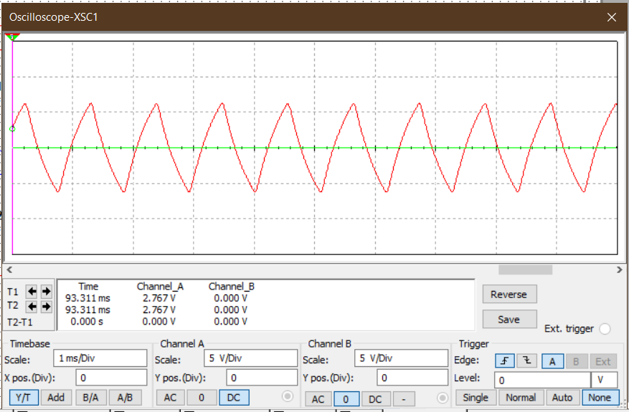

***Graph 1.2:*** *Input signal for a square wave generator using Op-Amp.*

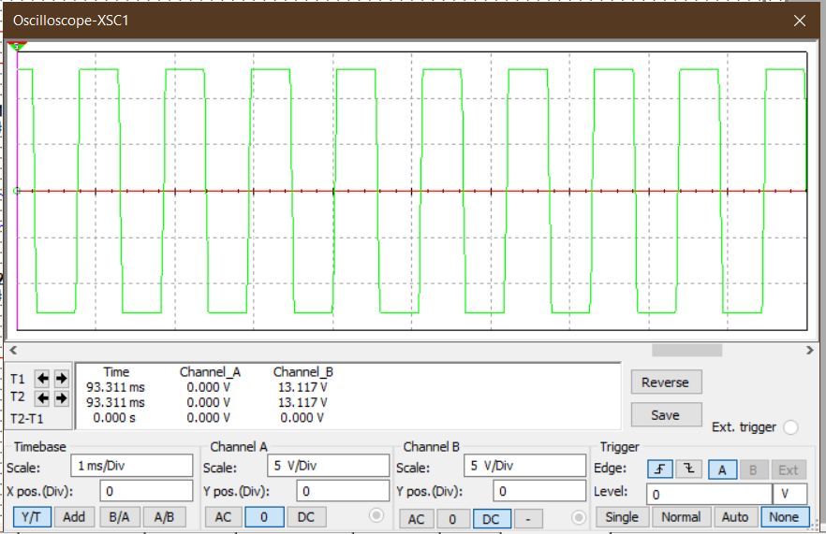

***Graph 1.3:*** *Output signal for a square wave generator using Op-Amp.*

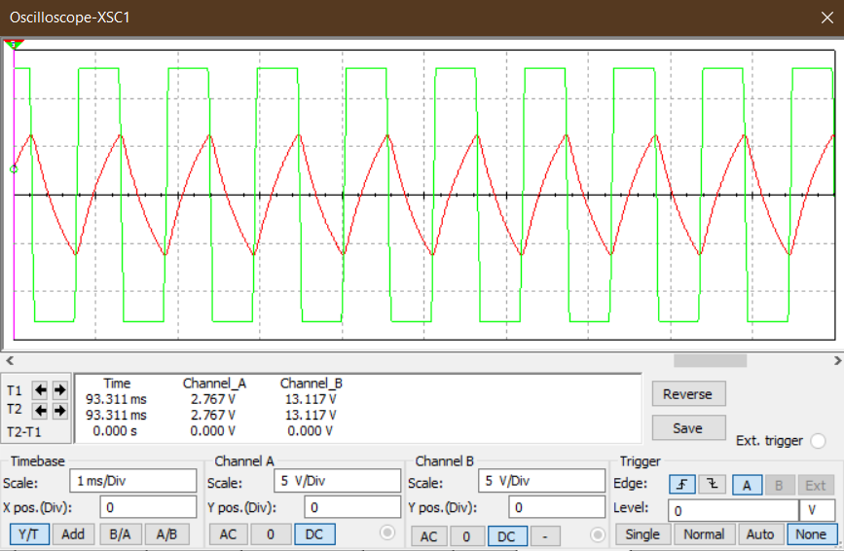

***Graph 1.4:*** *Input & Output signal for a square wave generator using Op-Amp.*

**Result:**

Here, in this experiment, the capacitor gets charged until it exceeds the upper threshold voltage and the capacitor gets discharged until it exceeds lower threshold voltage. This results in generating a square wave.

**Conclusion:**

In this experiment, there was an offset voltage at the non-inverting terminal and there was 0V at inverting terminal. So, Vd was greater than zero and output side became amplified to positive saturation voltage or +Vsat. This saturation voltage started to charge the capacitor through resistance R1. So, capacitor voltage started to increase as well as inverting terminal.

Thus, the capacitor was charged till ‘positive threshold voltage = R1*(+Vsat)/(R1+Rf)

When inverting terminal voltage greater than non-inverting terminal, Vd became less than zero and output side became negative saturation voltage or -Vsat.

Thus, the capacitor was discharged till ‘negative threshold voltage = R1*(-Vsat)/(R1+Rf).

This process is continuous and results in as square wave at the output. Thus, a square wave generator can be operated using op-amp.

*Heaven’s light is our guide.*

**Rajshahi University of Engineering and Technology**

**(RUET)**

**Department of Electrical & Electronic Engineering**

**Course no.** EEE2204

**Course title:** Electronics III Sessional

**Experiment no.** 10

# **Experiment name:** Experimental study of a triangular wave generator using Op-Amp.

**Submitted to:**

**Dr. Md. Samiul Habib**

Associate Professor

Dept. of Electrical & Electronic Engineering,

Rajshahi University of Engineering and Technology.

**Submitted by:**

**Ashraf Al- Khalique**

**Roll:** 1801171; **Session:** 2018-2019

Dept. of Electrical & Electronic Engineering,

Rajshahi University of Engineering and Technology.

**Date of experiment:** August 12, 2021.

**Date of submission:** November 20, 2021.

**Experiment no**. 10

**Name of the Experiment:** Experimental study of a *triangular* wave generator using Op-Amp.

**Objectives:** Followings are the main objectives of this experiment,

1. To understand the theory of operation of a triangularwave generator using Op-Amp.
2. To study the Op- Amp applications in a triangularwave generator using Op-Amp.
3. To observe wave shapes that meet a triangularwave generator using Op-Amp’s need.

**List of Components:**

1. Function Generator
2. DC power supply
3. Potentiometer (70kΩ; 1 piece, 30kΩ; 1 piece, 10kΩ; 1 piece)
4. Capacitor (0.01µF; 1 piece)
5. Oscilloscope
6. Op- Amp
7. Project board
8. Connecting wires
9. Simulator (Multisim 11.0)

**Circuit diagram:**



***Fig 1.2:*** *Circuit diagram for a triangular wave generator using Op-Amp.*

**Waveshape:**

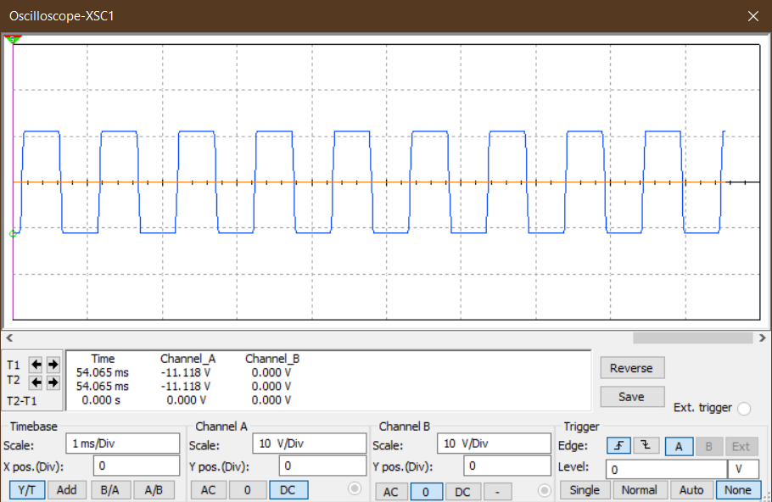

***Graph 1.2:*** *Input signal for a triangular wave generator using Op-Amp.*

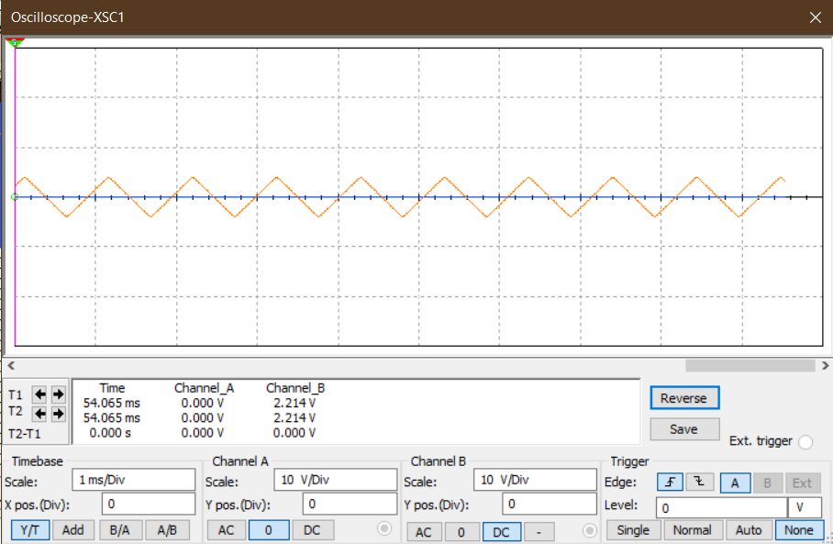

***Graph 1.3:*** *Output signal for a triangular wave generator using Op-Amp.*

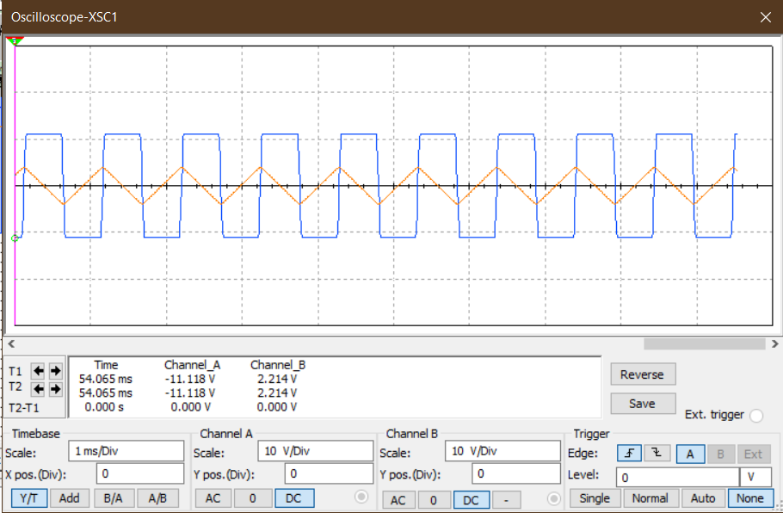

***Graph 1.4:*** *Input & Output signal for a triangular wave generator using Op-Amp.*

**Result:**

Here, in this experiment, square wave signal was given as input signal and due to cascaded circuit connection, a triangular waveform was observed with an amplitude lower than input.

**Conclusion:**

In this experiment, a square wave generator circuit was used which gave square wave input. This input signal got integrated by the cascaded integrator circuit. Here, integrator was connected at the inverting terminal thus output waveform got inversed of the input signal and started to change its peak after reaching its threshold voltage.

Again, the output triangular signal started to reduce its peak till reaches its lower threshold voltage.

Here, the threshold voltage of the positive peak of the triangular signal is,

+Vth = {R2*(+Vsat)}/R1

The threshold voltage for negative peak of triangular signal is,

-Vth = {R2*(-Vsat)}/R1